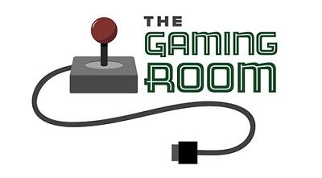

The Gaming Room

CS 230 Project Software Design Template
Version 1.0

Table of Contents

1.CS 230 Project Software Design Template 1
Table of Contents 2
Document Revision History 2
Executive Summary 3
Design Constraints 3
System Architecture View 3
Domain Model 3
Evaluation 3
Recommendations 5
2.Operating Platform: <Recommend an appropriate operating platform that will allow The Gaming Room to expand Draw It or Lose It to other computing environments.> 5
3.Operating Systems Architectures: <Describe the details of the chosen operating platform architectures.> 5
4.Storage Management: <Identify an appropriate storage management system to be used with the recommended operating platform.> 5
5.Memory Management: <Explain how the recommended operating platform uses memory management techniques for the Draw It or Lose It software.> 5
6.Distributed Systems and Networks: <Knowing that the client would like Draw It or Lose It to communicate between various platforms, explain how this may be accomplished with distributed software and the network that connects the devices. Consider the dependencies between the components within the distributed systems and networks (connectivity, outages, and so on).> 5
7.Security: <Security is a must-have for the client. Explain how to protect user information on and between various platforms. Consider the user protection and security capabilities of the recommended operating platform.> 5

Document Revision History

Version | Date | Author | Comments
1.0 | 05/27/22 | Matthew Nees | Addition of a new Entity Class, changes to extension of multiple classes from Entity Class

Instructions
Fill in all bracketed information on page one (the cover page), in the Document Revision History table, and below each header. Under each header, remove the bracketed prompt and write your own paragraph response covering the indicated information.

Executive Summary

The Gaming Room, the current owners of an Android app called Draw It or Lose It, is wanting to develop a web-based version of their current game to be supported across multiple platforms. As well, the web-based version will continue to use the existing functionality of the current game for the other platforms. Our solution will involve looking at the specified constraints to better decide our direction in develop to accomplish the goal of a multi-platform game.

Design Constraints

- A game will have the ability to have one or more teams involved.
- Each team will have multiple players assigned to it.
- Game and team names must be unique to allow users to check whether a name is in use when choosing a team name.
- Only one instance of the game can exist in memory at any given time. This can be accomplished by creating unique identifiers for each instance of a game, team, or player
- Multi-platform connectivity

All of the design constraints above and much that development could be streamlined using the existing code base from the Android version as a framework for other platforms. However, a major constraint will be the interaction of the game with itself across multiple platforms highlighted by the last design constraint. It would require a large bulk of the development creating the means for version to have inter-connectivity.

System Architecture View

Please note: There is nothing required here for these projects, but this section serves as a reminder that describing the system and subsystem architecture present in the application, including physical components or tiers, may be required for other projects. A logical topology of the communication and storage aspects is also necessary to understand the overall architecture and should be provided.

Domain Model

Our Game, Team, and Player classes all have an inheritance relationship from our Entity class. The idea is to seemingly cut down on the potential for redundant code likely used in each class. As well our Game, Team and Player classes have a 'has-a' or aggregation relationship between each other. Our GameService Class has a reference through our Game class with no direct inheritance to Entity.
The ProgramDriver and SingletonTester classes has a use relationship where the execution occurs in the ProgramDriver and uses from the SingletonTester class as needed.

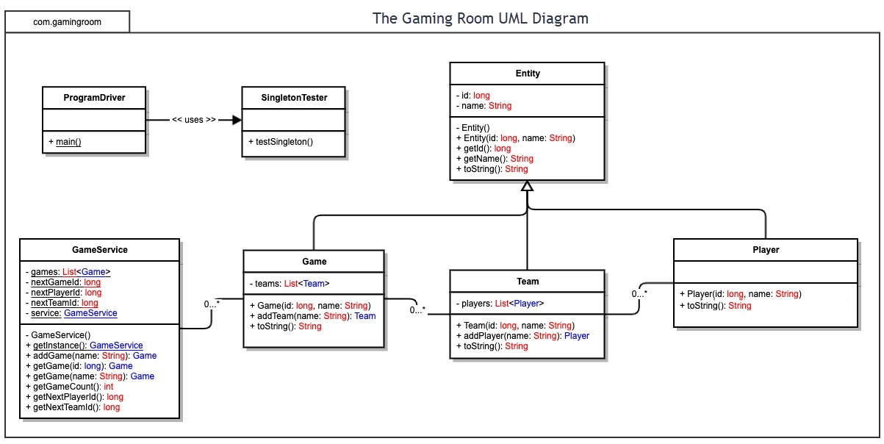

Evaluation

Development Requirements | Mac | Linux | Windows | Mobile Devices
Server Side | Excellent graphic interface with ease of use. Easiest to understand, best accessibility and best server configuration tools. | Lowest cost of server capabilities and open source. Limited in the amount of users with knowledge and familiarity in using or running Linux based servers. | Most user friendly in design from the list but carries the highest cost for usage. Plenty of environments and software options with Windows related servers. | Servers vary from platform to platform. Cheap option with more work related requirements on the the back-end to connect each to each other. Compatibility will be an issue.
Client Side | Most likely to be the most expensive options to the user. Functionality and user interfaces, while modern, tend to be a bit clunky to play around with. Large amount of knowledge around IOS application development and quick creation. | Would require the most time for development. We would be drawing from a much smaller group of people with understanding. Low cost to the user ultimately with the constraints being on a small knowledge pool of Linux systems. | Easiest to understand including support of a Windows product. Cost would be mid-tier between Mac and Linux in terms of costs, however, most knowledge to develop of all the platforms. | Most time spend to maintain a mobile application between the varying OS as well as keeping them connected. May take the longest to develop and on the high end to costs once created and to maintain.
Development Tools | Relevant languages include JavaScript, HTML, CSS, Python, and Swift.  Major tools include Visual Studios, Eclipse IDE, and Atom.  Most expensive long term options and limited market from the PC side, however, easily handles some of the largest sources from IOS standpoint. | Relevant languages like Mac.  Major tools include Netbeans, Vim, Eclipsed IDE, and Geany.  Much cheaper options with the open-sourced nature of Linux compared to Mac. | Relevant languages include JavaScript, HTML, C#, and Python.  Major tools include Visual Studios, PyCharm and IntelliJ.  On par funding requirements to mobile, however, more expensive than Linux. | Relevant languages like Windows to include C++ and React.  Major tools similar as Windows to include Xcode.

Recommendations

- Operating Platform: For the web-based version of Draw It or Lose it would be a Windows OS product. Not only with the number of tools and usability of all the languages in the Window's development environments but they can be easier to maintain and expand with future features and investments. As well, Windows OS has so many options readily available to support whatever needs required to include database management, file servers, web servers, etc.

- Operating Systems Architectures: Our main draw to recommending a Windows server operating architecture is the main concepts of memory and file management. The GUI of Windows allows for easier configuration and development of applications creating the ease for longevity of the operating platform and the work that occurs on it.

- Storage Management: With standard disk management and storage sense systems already being built into Windows provides areas that do not require the end to be built but also have the means to deal with potential issues. Cleanup tools and the utility within the OS create advantages in storage other OS's do not offer.

- Memory Management: Through languages like C++ we have direct use of stack and heap allocations in our applications to create more efficient and faster product where others may not. Window OS again proves to be the best choice for this area and game development as well many server-side storage systems use Python as a main language for this.

- Distributed Systems and Networks: Client-Server distribution systems will provide the means to handle multi-platform-based game. Without having to do it via solely through one lane means we can deploy our game and future updates at the same time. It allows the user to use their preferred client without having to be limited to different versions if they decide to switch. This as well hinges on good server-side compatibility and support provided us the needed link from the client application to one another.

- Security: Much of our security will be built through depth. Using Windows OS built in Defender application in conjugation with encrypt of data should provide a strong foundation to which security is built. On top of that we would look to recommend a client side two-factor authentication system and real-time link client related system to shield user related data from being access or stolen. Neither of the other two architectures have the robust nature of Windows in this application of security.

